**Customer’s User Interface:**

A customer’s user interface consists of pages which allows the customer to shop for their items.The customer is allowed to signup/login and after identification,the customer can view his/her cart,favourites,recently viewed items and special offers or discounts.

The customer can interract with the products,add/remove items from the cart,view details about the website as well as the top products trending.

Once the customer is done he/she can check out and an auto generated bill will be displayed.

The customer’s user interface consists of the following:

* **Index/Main Page:**

This page is the first page and allows the customer to interract with all the features the website offers.

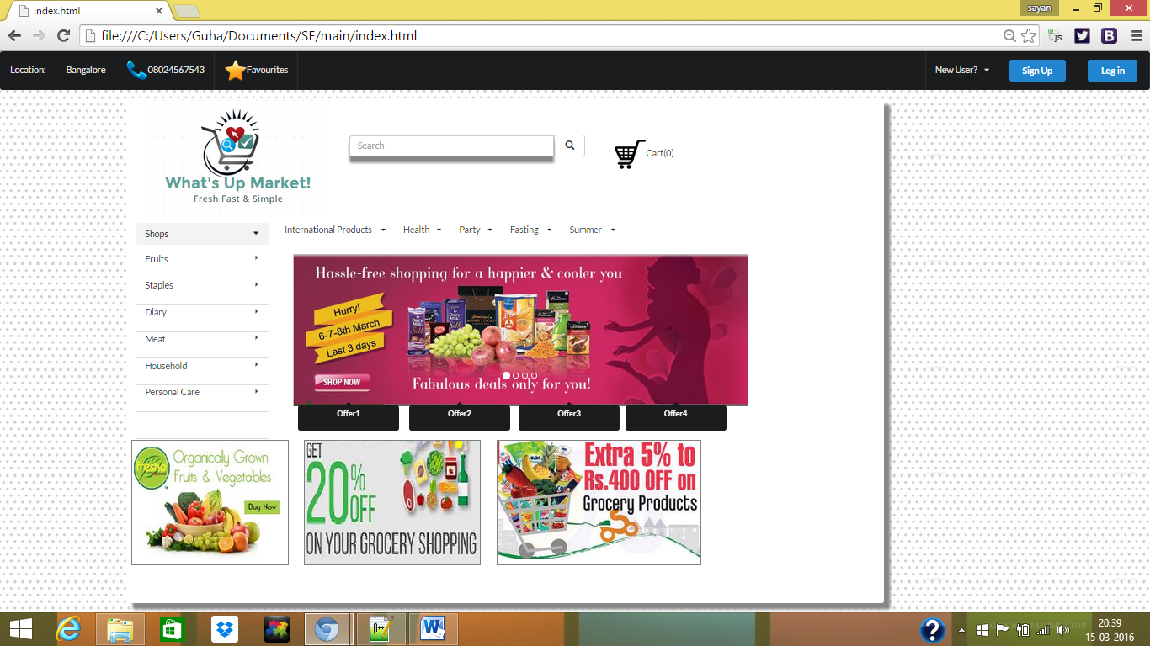

* **Sign Up page:**

The webiste consists of a 3 stage sign Up page,which allows the user to sign up and allows “What’s Up Market” to uniquely identify the customer.

Page 1:

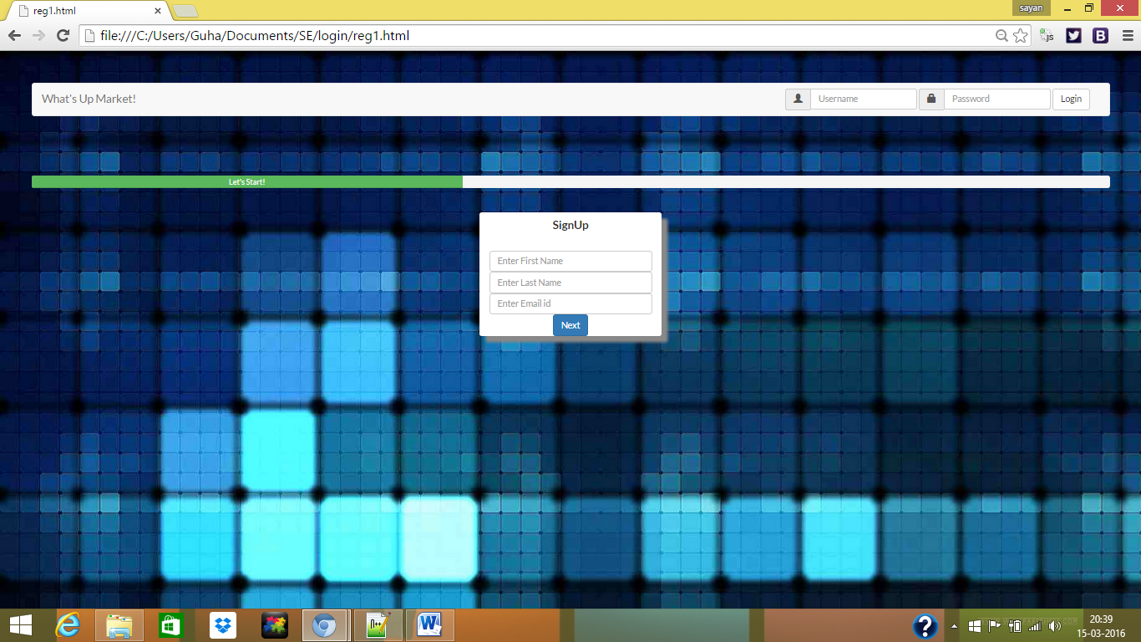

Page 2:

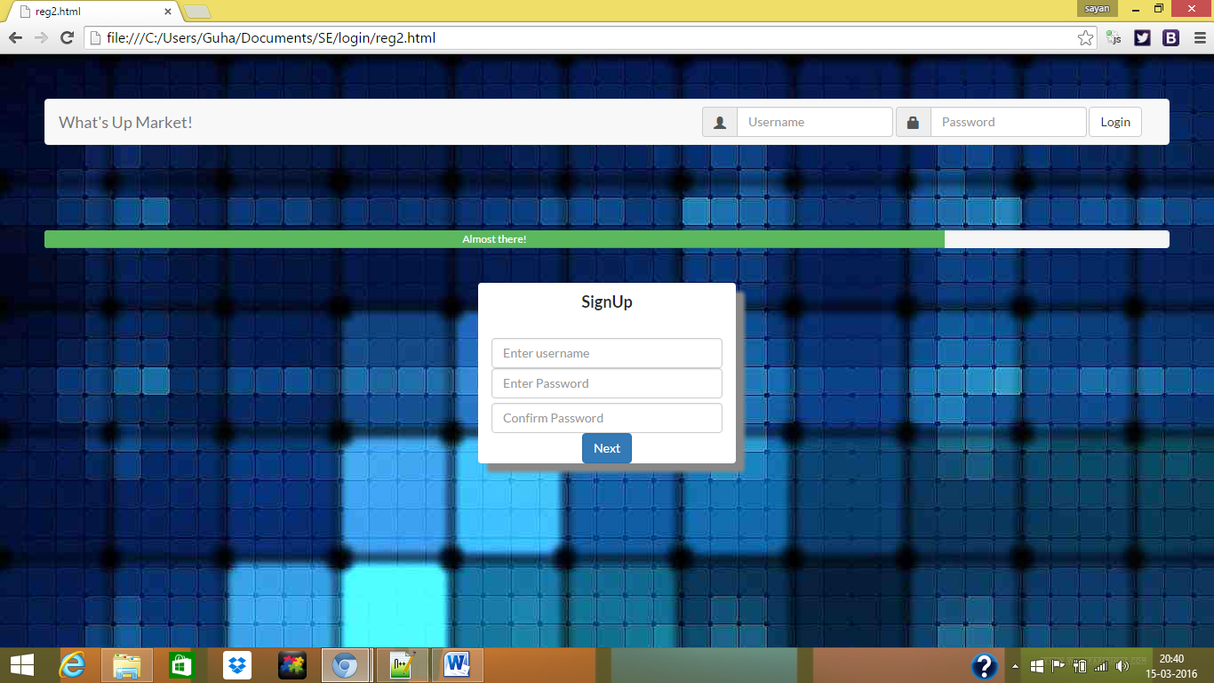

Page 3:

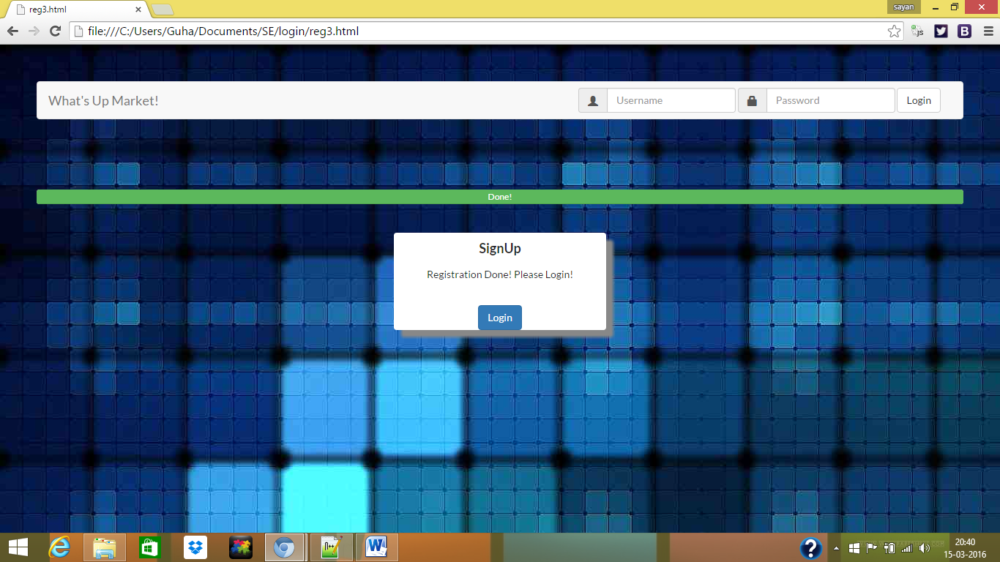

* **Login:**

Login page allows the customer to login and allows the website to track him/her.

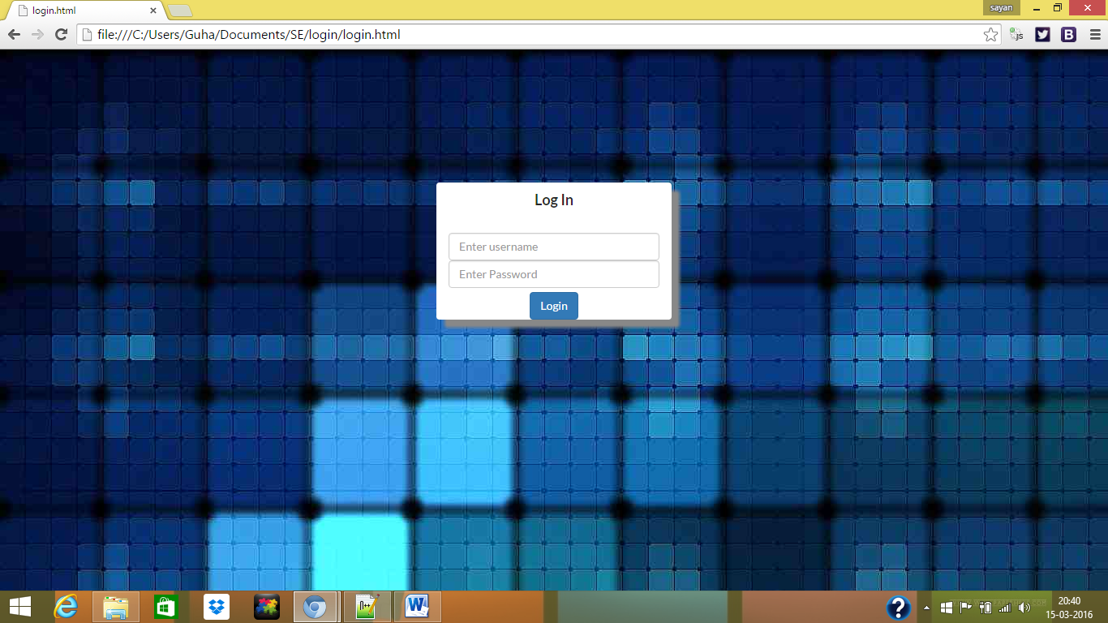

* **Cart Page:**

This page allows the customer to check what the customer has in his/her cart, add/remove items and move to generate the bill page.

The basic template is below:

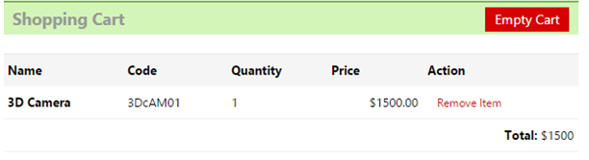

* **Product Catalogue page:**

This page allows users to add items to cart.

Basic template given below.

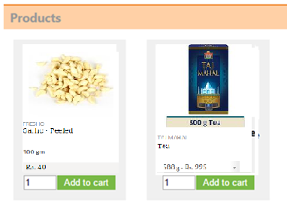

* **Generating the Bill:**

This page generates the bill after the User has checked out.

* **Miscellaneous Pages:**

This consists of pages which has simple HTML describing details about the website. For Eg. Pages such as About Us, What is “what’s Up market”, The Team, Contact us etc.